# UNIT 2 VECTORS IN TWO DIMENSIONS

## 2.1 Vectors

Vectors are fundamental objects in applied mathematics; they efficiently convey information about a mathematical or physical object. Let's get a sense of what they are.

A **VECTOR** is a representation of an object that has both direction and magnitude. By direction, we mean the place toward which something faces, and by magnitude, we mean the size of something.

A vector can be depicted visually by an arrow, with an initial point called the tail and a terminal point called the head. The length of the arrow represents the vector's magnitude.

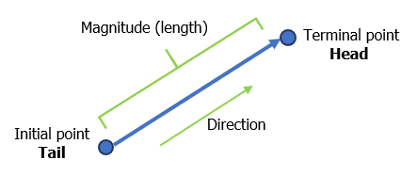

Vectors are often named using a bold-typed letter with an arrow on top of it. For example, the vector in the picture could be named or .

An example of a vector is a car’s velocity. Velocity is a vector since it has both magnitude (speed) and direction. A car might be moving west at 60 mph. Other examples of vectors are displacement, acceleration, and force.

The temperature of some medium is not a vector since it has only magnitude. But if the medium is being heated, its temperature is increasing and has a direction; it is going upward. The increase or decrease in temperature is a vector.

### VECTORS IN STANDARD POSITION

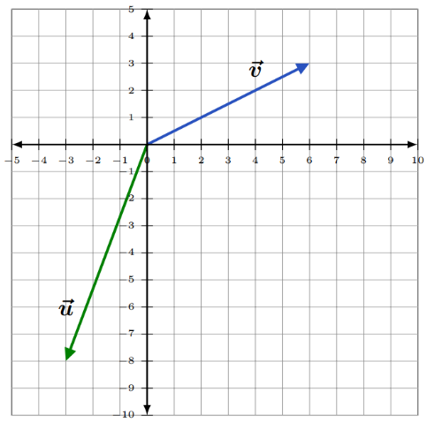

A vector with its initial point at the origin in a Cartesian coordinate system is said to be in STANDARD POSITION. The vector in the diagram has its initial point at the origin, and its terminal point at.

### COMPONENTS OF A VECTOR

Vectors in the -plane can be broken into their **horizontal** and **vertical** components.

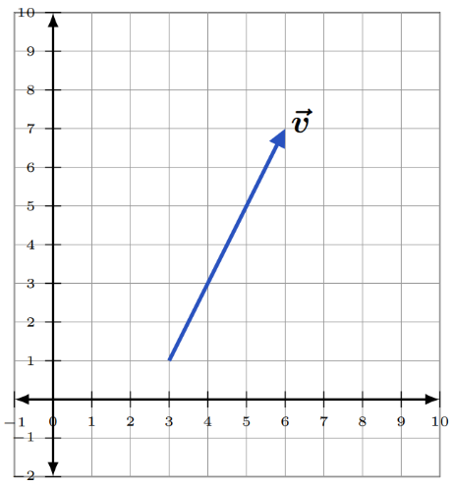

For example, the vector in the diagram  
can be broken into two components,

1. its horizontal, or -component, and
2. its vertical, or -component.

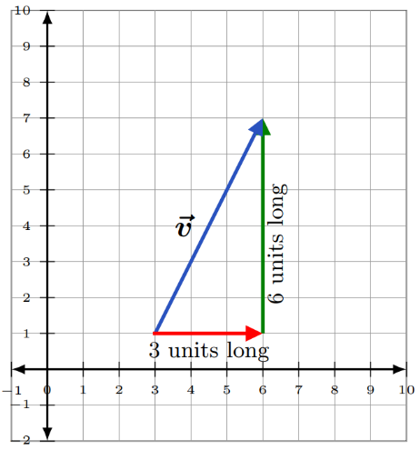

The vector in component form is expressed using angle brackets as , where

1. the first component, 3 is the length and direction of its

-component, and

1. the second component, 6 is the length and direction of its -component.

The vector in the picture below has

**FIRST COMPONENT = (terminal -value) – (initial -value)** = , and

**SECOND COMPONENT = (terminal -value) – (initial -value)** = ,

so that .

**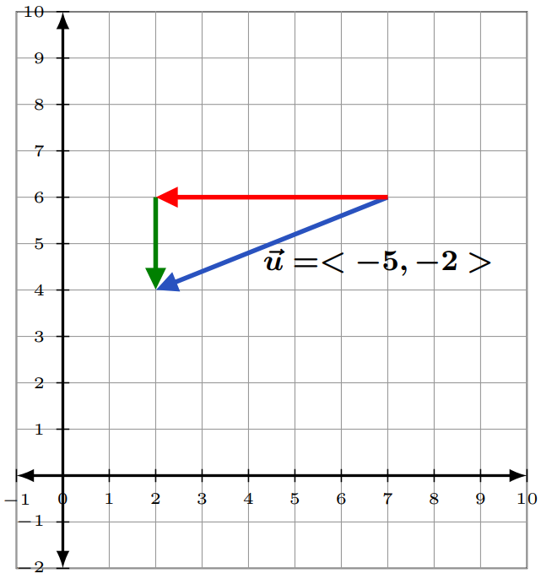**

### ROW AND COLUMN FORMS OF A VECTOR

Vectors are represented by a single column matrix or a single row matrix. The vectors , and

above, can be represented by the 2x1 row matrix and the 1x2 column matrix, respectively as

and

### EQUAL VECTORS

Two vectors are EQUAL if they have the same direction and magnitude. They may start and end at different positions, but their representing arrows will be parallel.

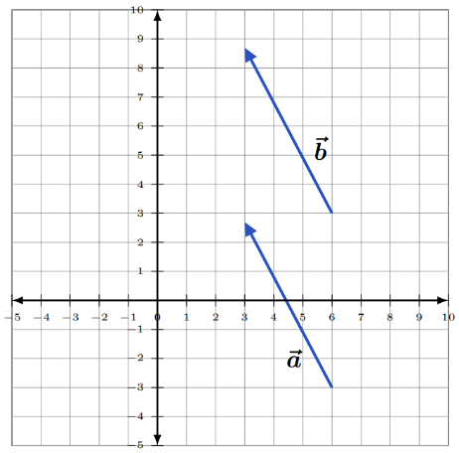

In the diagram vectors and are equal but appear in different locations in the -plane.

### 2.1 TRY THESE

1. Express the vectors and in component form.

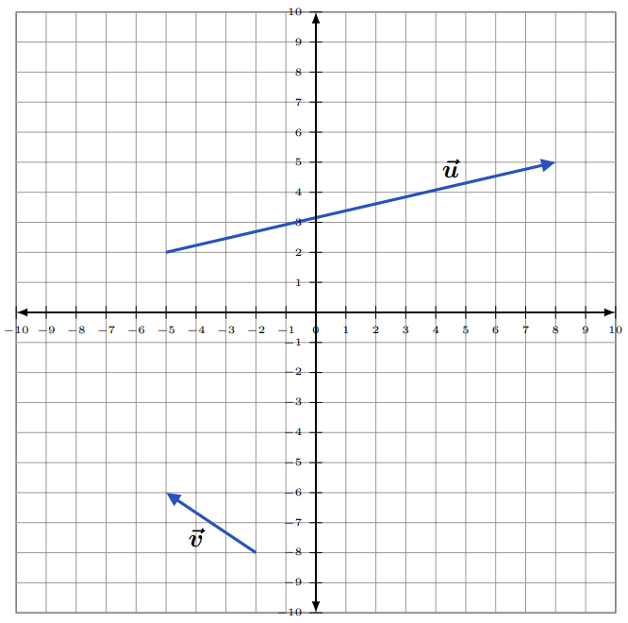

1. Explain why the two vectors are equal.

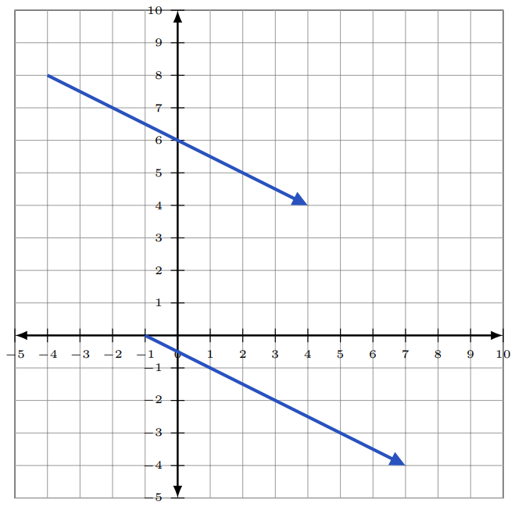

## 2.2 Addition, Subtraction, and Scalar Multiplication of Vectors

### ADDITION & SUBTRACTION OF VECTORS

To add or subtract two vectors, add, or subtract their corresponding components.

To **ADD** the vectors and , begin by writing each in component form.

Example (1)

|  |  |
| --- | --- |
| This image shows the starting points of the two vectors v and u connected together at (0,0), but pointing in different directions. The terminal point for vector v (6,3) and for u, the terminal point if (negative 3,8). | and  ADD their corresponding components.  So, |

|  |  |
| --- | --- |
| Now, graph this sum.   * Start at the origin. * Since the horizontal component is 3, move 3 units to the *right*. * Since the vertical component is , move 5 units *downward*. | Image of two vectors and a demonstration of graphing their sum. Here are the same vectors  v and u. There is a third vector in between called  u + v.  The starting points for all of the three vectors is (0,0). The ending point of vector v is (6,3), the ending point for vector u is (negative 3, negative 8). The ending point of u + v is (3, negative 5). |

The addition of two vectors and can be demonstrated by placing the tail of one vector at the head of the other. Then connect the tail of to the head of .

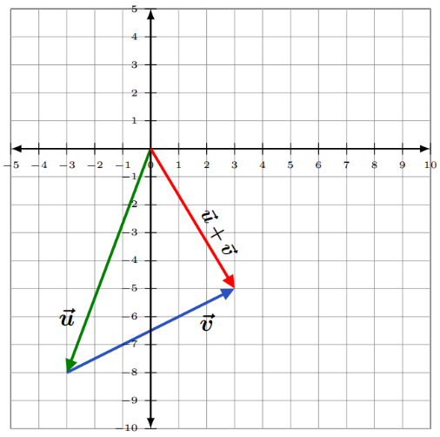

To **SUBTRACT** the vector from the vector , begin by writing each in component  
 form.

Example (2)

|  |  |
| --- | --- |
| Image of two vectors v and u pointing in  different directions with the same starting point at (0,0). The terminal point of vector v is (6,3) and the terminal point of vector u is ( negative 3, negative 8). | and  SUBTRACT the components of from the corresponding components of .  So, |

|  |  |
| --- | --- |
| Now, graph this sum.   * Start at the origin. * Since the horizontal component is 9, move 9 units to the *right*. * Since the vertical component is 11, move 11 units *upward*. | Image of vectors v and u and an example of graphing their subtraction which produces vector v - u. The starting point of vector v - u is (0,0) and the terminal point is (9,11). |

### SCALARS

In contrast to a vector, and having both direction and magnitude, a SCALAR is a physical quantity defined by only its magnitude.

Examples are speed, time, distance, density, and temperature. They are represented by real numbers (both positive and negative), and they can be operated on using the regular laws of algebra.

The term *scalar* derives from this usage: *a scalar is that which scales, resizes a vector*.

Scalar multiplication is the multiplication of a vector by a real number (a scalar).

Suppose we let the letter represent a real number and be the vector Then, the scalar multiple of the vector is

To multiply a vector by a scalar (a constant), multiply each of its components by the constant.

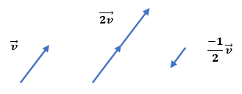

1. Suppose and .

Then

1. Suppose and .

Then

1. Suppose and .

Then

### USING TECHNOLOGY

We can use technology to add and subtract vectors and to multiply a vector by a scalar.

Go to www.wolframalpha.com.

For the vectors and , use WolframAlpha to find . Enter evaluate 3<-2, 6> + 4<5, 3> in the entry field. Wolframalpha tells you what it thinks you entered, then tells you its answer. In this case, .

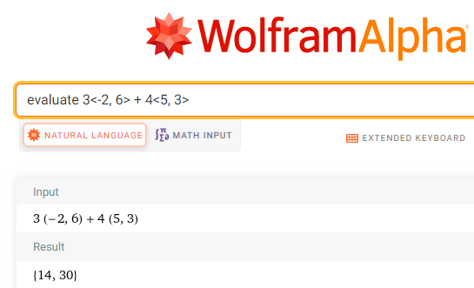

### 2.2 TRY THESE

1. Find the sum of the two vectors and .
2. Subtract the vector from the vector .
3. Suppose , , and . Perform the operation .

## 2.3 Magnitude, Direction, and Components of a Vector

### THE MAGNITUDE OF A VECTOR

It is productive to represent the horizontal and vertical components of a vector as and , respectively.

|  |  |
| --- | --- |
| The magnitude (the length) of a vector is | A diagram showing the magnitude of a vector and its horizontal and vertical components. v_x (v subscript x) is pointing horizontally and v_y (v subscript y) is pointing vertically. The terminal point of v_x is connected to the starting point of v_y. The starting point of vector v is connected to the starting point of v_x. The terminal point of vector v is connected to the terminal point of v_y. |
|  |  |

|  |  |
| --- | --- |
| The vector has magnitude:    = =  Interpret this as the length of the vector is units. | An example of a vector magnitude in a 2-dimension coordinate system. The starting point of vector v is (0,0) and the terminal point is (5,negative 8). The magnitude of vector v is square root of 89. |

### THE DIRECTION OF A VECTOR

The direction of a vector is the angle the vector makes with the positive -axis.

It is typically represented with the uppercase Greek letter theta . We use some trigonometry to determine the angle .

|  |  |
| --- | --- |
| or  The angle is always between 0° and 360°. | Image illustrating a direction of a vector and the angle it makes with the positive x-axis. Vector v is theta degrees away from the x-axis. The y-axis is 90 degrees away from the x-axis. Vector v is 90-theta degrees away from the y-axis. |

To approximate the direction of the vector , use with and

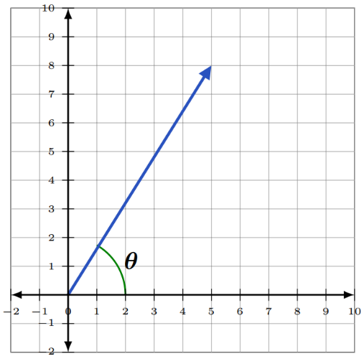

Using a calculator, we get

To approximate the direction of the vector , use with and

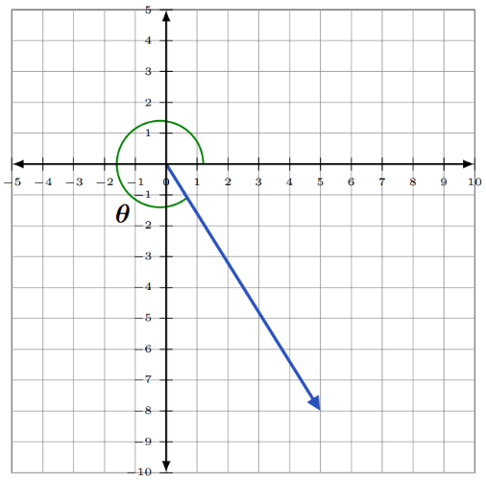

Using a calculator, we get

Vertical component is in Quadrant IV and must be in the interval , therefore we calculate by

### THE COMPONENTS OF A VECTOR

The lengths of the - and - components of a vector

in two dimensions can be found using trigonometric ratios.

and

is the horizontal component of and is the vertical component.

The angle is always between 0° and 360°.

Suppose the magnitude of a vector is 20 units, and that makes a 60° angle with the horizontal. Then, the components of are

and

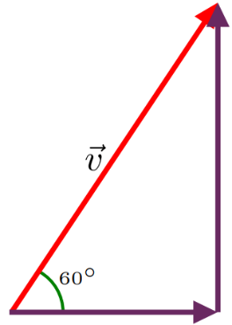

So, we could write as

### 

### USING TECHNOLOGY

We can use technology to determine the magnitude of a vector.

Go to www.wolframalpha.com.

To find the magnitude of the vector enter magnitude of the vector <2,4> in the entry field. Wolframalpha tells you what it thinks you entered, then tells you its answer. In this case, .

**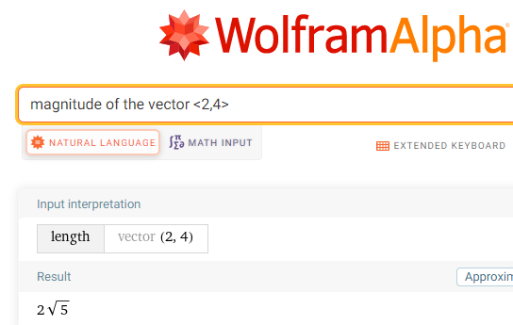**

To find the direction of the vector enter direction of the vector <5,8>in the entry field. Wolframalpha answers .

**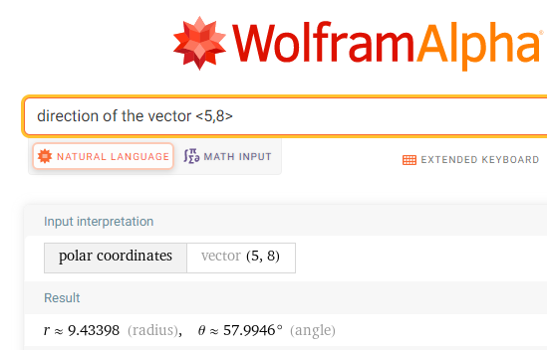**

### 2.3 TRY THESE

1. Find the magnitude of the vector
2. Find the magnitude of the vector
3. Find the components of the vector if the magnitude of is 6 and it makes a 30° angle with the horizontal.
4. Approximate the direction of the vector .

## 2.4 The Dot Product of Two Vectors, the Length of a Vector, and the Angle Between Two Vectors

### THE DOT PRODUCT OF TWO VECTORS

The length of a vector or the angle between two vectors and can be found using the dot product.

The dot product of vectors and

is a scalar (real number) and is defined to be

Since and are real numbers, you can see that the dot product is itself a real number and not a vector.

To compute the dot product of the vectors and , we compute

Example (1)

Since the dot product is a scalar, it follows the properties of real numbers.

**PROPERTIES OF THE DOT PRODUCT**

1. , the dot product is commutative
2. , the dot product distributes over vector addition
3. , the dot product with the zero vector , is the scalar 0.

Compute the dot product ,

Example (2)

where , , and .

### THE LENGTH OF A VECTOR

The length (magnitude) of a vector you know is given by . The length can also be found using the dot product. If we dot a vector with itself, we get

By Vector Property 4, . This gives .

Taking the square root of each side produces

Which is the length of the vector .

The dot product of a vector with itself gives the length of the vector.

Use the dot product to find the length of the vector .

Example (3)

In this case, and

Using , we get

The length of the vector is units.

### THE ANGLE BETWEEN TWO VECTORS

The dot product and elementary trigonometry can be used to find the angle between two vectors.

If is the smallest nonnegative angle between two non-zero vectors and , then

cos or

where and and

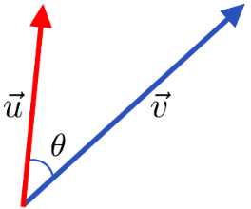

Find the angle between the vectors and .

Example (4)

Using , we get

We conclude that the angle between these two vectors is close to 94.4°.

### USING TECHNOLOGY

We can use technology to find the angle between two vectors.

Go to www.wolframalpha.com.

To find the angle between the vectors and , enter angle between the vectors <5, -3> and <2, 4> in the entry field. Wolframalpha tells you what it thinks you entered, then tells you its answer. In this case, , rounded to one decimal place.

**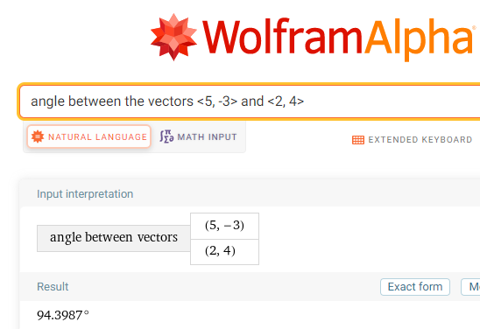**

### 2.4 TRY THESE

1. Find the dot product of the vectors and .
2. Find the dot product of the vectors and .
3. Find the length of the vector .
4. Find the length of the vector .
5. Find the angle between the vectors and .
6. Find the angle between the vectors and .

## 2.5 Parallel and Perpendicular Vectors, The Unit Vector

### PARALLEL AND ORTHOGONAL VECTORS

Two vectors and are **parallel** if the angle between them is 0° or 180°.

Also, two vectors and are parallel to each other if the vector is some multiple of the vector .That is, they will be parallel if the vector , for some real number . That is, is some multiple of .

Two vectors and are **orthogonal** (perpendicular to each other) if the angle between them is 90° or 270°.

Use this shortcut: *Two vectors are perpendicular to each other if their dot product is 0.*

The two vectors and are parallel to each other since the angle between them is .

Example (1)

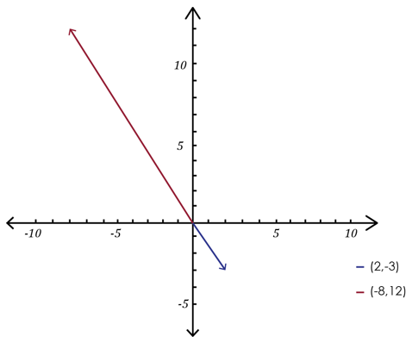

To show that the two vectors and are orthogonal (perpendicular to each other), we just need to show that their dot product is 0.

Example (2)

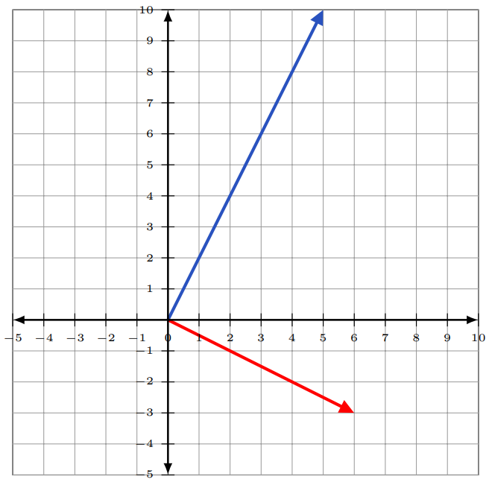

### THE UNIT VECTOR

A unit vector is a vector of length 1.

A unit vector in the same direction as the vector is often denoted with a “hat” on it as in . We call this vector “v hat.”

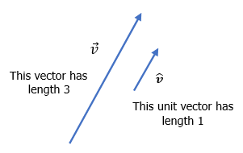

The unit vector corresponding to the vector is defined to be

The unit vector corresponding to the vector is

Example (3)

### USING TECHNOLOGY

We can use technology to find the angle between two vectors.

Go to www.wolframalpha.com.

To show that the vectors and are parallel,enter angle between the vectors <2, -3> and <-8, 12> in the entry field. Wolframalpha tells you what it thinks you entered, then tells you its answer. In this case, , indicating the two vectors are parallel.

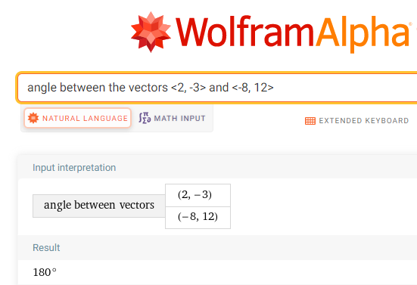

### 2.5 TRY THESE

1. Determine if the vectors and are parallel to each other, perpendicular to each other, or neither parallel nor perpendicular to each other.

1. Determine if the vectors and are parallel to each other, perpendicular to each other, or neither parallel nor perpendicular to each other.

1. Determine if the vectors and are parallel to each other, perpendicular to each other, or neither parallel nor perpendicular to each other.

4.Find the unit vector corresponding to the vector .

## 2.6 The Vector Projection of One Vector onto Another

### PROJECTION

Let’s project vector onto the vector .

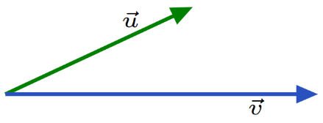

To do so, imagine a light bulb above shining perpendicular onto .

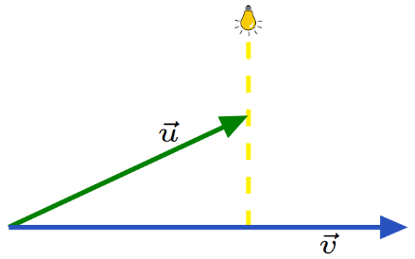

The light from the bulb will cast a shadow of onto ,and it is this shadow that we are looking for. The shadow is the projection of onto .

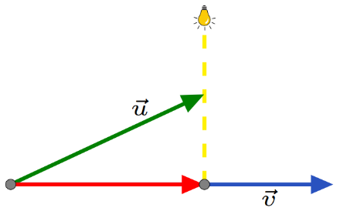

The red vector is the projection of onto . The notation commonly used to represent the projection of onto is .

Vector parallel to with magnitude in the direction of is called projection of onto .

The formula for is

To find the projection of ⟨4, onto ⟨2, , we need to compute both the dot product of and , and the magnitude of , then apply the formula.

Example (1)

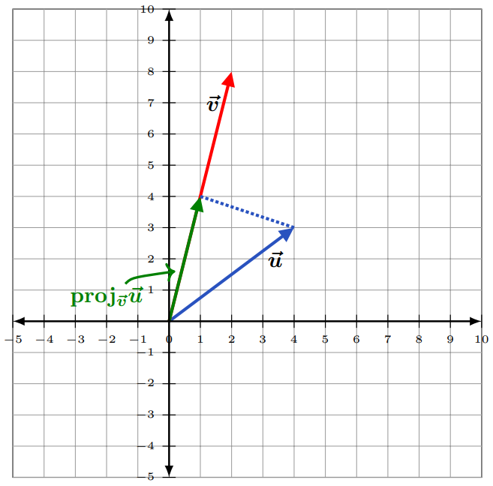

### USING TECHNOLOGY

We can use technology to determine the projection of one vector onto another.

Go to www.wolframalpha.com.

To find the projection of onto ⟨2, , use the “projection” command. In the entry field enter projection of <4, 3> onto <2, 8>.

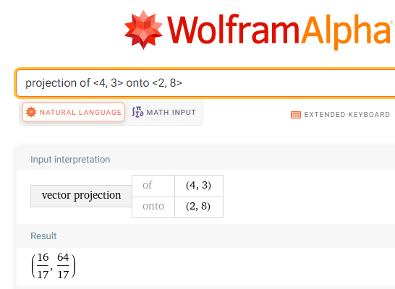

Wolframalpha tells you what it thinks you entered, then tells you its answer. In this case, .

As an applied example, suppose a video game has a ball moving near a wall.

Example (2)

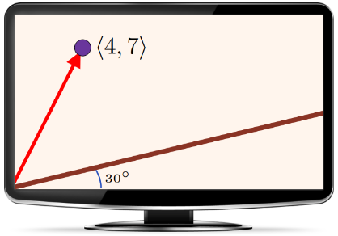

We take the origin at the bottom-left-most corner of the screen. The wall is at a 30° angle to the horizontal, and at a point in time, the ball is at position ⟨4,. To find the perpendicular distance from the ball to the wall, we use the projection formula to project the vector ⟨4, onto the wall.

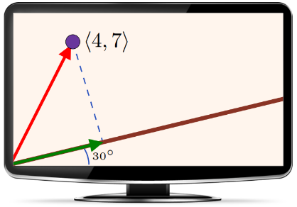

We begin by decomposing into two vectors and so that and lies along the wall**.**

**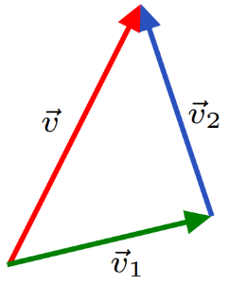**

The length (magnitude) of the vector is then the distance from the ball to the wall.

The vector is the projection of onto the wall. We can get by scaling (multiplying) a unit vector that lies along the wall and, thus, along with .

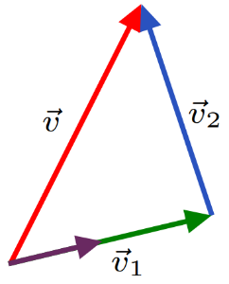

Since lies at a 30° angle to the horizontal, , using the projection formula, we get the projection of that lies along the wall.

|  |
| --- |
|  |

|  |  |
| --- | --- |
| Since that , subtraction get us  To get the magnitude of , we use | An image exampling a monitor with a ball and vector movement creating an angle and showing the projection of the vector with its measurements. The starting point of the vector <4,7> is connected to the bottom left of the screen as well, with the ball connected to the terminal point of <4,7>. There is a green vector that is 30 degrees away from the bottom of the screen. There is also a dotted line that connects both the terminal points of <4,7> and the green vector together. The dotted line is 4.016 units long. Finally, there is a brown line that connects the terminal point of the green vector and the right side of the screen. This brown line is parallel to the green vector. |

### 2.6 TRY THESE

1. Find the projection of the vector onto the vector .
2. Find , with and .